《在线课堂》学习单
班级： 姓名：

单元 | 五年级下册Unit 5 My Favorite Activities
课题 | V&T
温  故  知  新 | 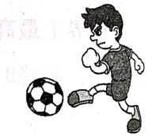  看图，完成对话。  A:What is Tony going to do?  B:He's going to .  2. A:What are they going to do?  B: They’re going to .  3. A:Are you going to ?  B:Yes, I am.
自  主  攀  登 | 中英文匹配。  1. ( ) once A.去游泳  2. ( ) twice B.去溜冰  3. ( ) three times C.去钓鱼  4. ( ) often D.经常  5. ( ) go fishing E.三次  6. ( ) go hiking F.一次  7. ( ) go ice-skating G.两次  8. ( ) go swimming H.去远足；去徒步
稳  中  有  升 | 根据中文意思，填入所缺单词。  - I (去远足) about (三次) a year.  - She (去钓鱼) about (一次) a week.  - He (去露营) about (两次) a year.  - They (去游泳) about (四次) a month.  - We (去溜冰) about (五次) a year.
说句心里话

