《在线课堂》学习单
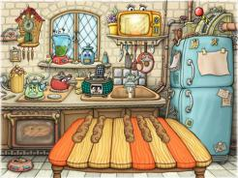
班级： 姓名：
单元 | 四年级下册Unit 6 Jobs
课题 | Vocabulary and Target
温  故  知  新 | Look, choose and write.看图选词填空。  What Whose Where Who  - -____________are you going,Lisa? -I’m going to the supermarket.  - -_________is she ? -She’s my sister.  - -_________shirt is it?-It’s Jenny.  - -_________do they want? -They want a computer game.
自  主  攀  登 | Choose and write.选词填空。  firefighter family doctor taxi driver  Hello.I’m Tim.Look at this picture.This is my__________.That’s my father.He’s a ___________.He often goes to the fire fighting.That’s my mother.She’s a ____________. This is my brother.He works in a big hospital. He’s a ___________.This is me.I’m a pupil.I love my family.
稳  中  有  升 | Read and choose.选出相应的答句。  A: No,he isn’t.  B: I want to be a magician.  - Yes,he does.  - I am a police officer.  - I am going to the hospital.  ( ) 1.What do you do ?  ( ) 2.Where are you going?  ( ) 3.What do you want to be?  ( ) 4.Is your father an office worker?  ( ) 5.Dose he want to be a taxi driver?
说句心里话

