《在线课堂》学习单
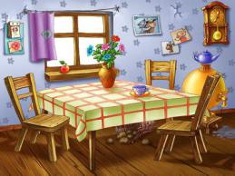
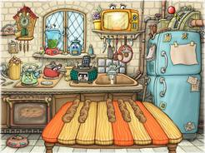
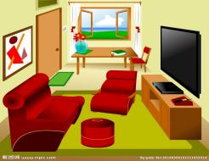
班级： 姓名：
单元 | 四年级下册Unit 8 Weekend Fun
课题 | Vocabulary and Target
温  故  知  新 | Look, choose and write.看图选词填空。  go to the park surf the Internet play outside  1._______________ 2._________________ 3._________________  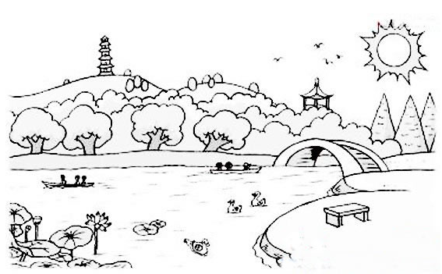  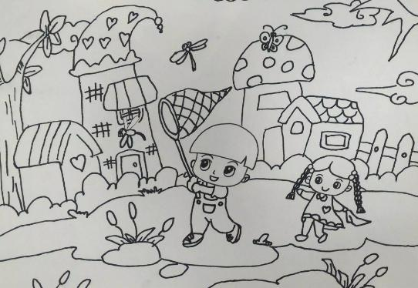
自  主  攀  登 | Choose and write.选词填空。  snowman park surfing play  1.Do you want to go to the__________?  2.Let’s make a _______________.  3.I want to ______________outside.  4.He is ______________the Internet.
稳  中  有  升 | Read and choose.选出相应的答句。  - I am reading a book.  - Yes, I do.  - Not really.  - I want to play outside.  - She wants to read a story.  ( ) 1.What do you want to do ??  ( ) 2.Do you want to make his head?  ( ) 3. What does she want to do?  ( ) 4.Does he want to listen to music?  ( ) 5.What are you doing?
说句心里话

