《在线课堂》学习单
班级： 姓名：
单元 | 英语4年级上册Unit 1
课题 | School Subjects (Vocabulary and Target)
温  故  知  新 | 根据句意，选词填空。  ( apple soccer )  - -- What is this? --- It’s an ______________ .  2.--- Do you like-______________ ? ---Yes, I do
自  主  攀  登 | Read and write. 看图填空，每空一词。  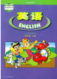 1. A: Do you like ________? B: Yes, I do.  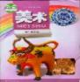 2. A: What subjects do you like? B: I like ___________.  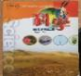 3. A: Do you like __________? B: No, I don’t.  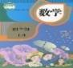 4.A: Do you like___________? B: Yes, I do.
稳  中  有  升 | Read and write.看图填空。  1. Do you like _________ ? Yes, I _____.  2. What___________ do you like? I like______.  3．____ you like ______? No, I _____.  ____ ________do you like? I like _____ and _____ .
说句心里话

