《在线课堂》学习单
班级： 姓名：
单元 | 英语4年级上册Unit 3
课题 | My Week (Vocabulary and Target)
温  故  知  新 | Read and write.根据句意，选词填空。  ( basketball soccer baseball ）  1.—Can you play_____(棒球) ---Yes, We can.  2.--- Let’s play_____________(英式足球)  3.---Do you like__________(篮球)？---Yes, I do
自  主  攀  登 | Read and write. 根据括号内的中文意思填空。  - A:What day is it today?  B: It’s_____________.（星期三）  - A: Do you swim on ____________? （星期二）  B: Yes, I do.  - A: What do you do on ___________? （星期五）  B: I play ping-pong.  - A: It’s ____________ today. Let’s go to the park. （星期天）  B: OK.  - A: Do you play tennis on ___________? (星期一）  B: Yes, I do.
稳  中  有  升 | 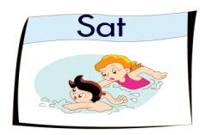  Read and write看图填空。  - We_______ on __________.  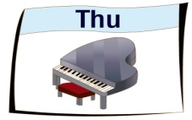  2. I play ______ ________on ____________.  3. I _______ _________ on____________ .
说句心里话

